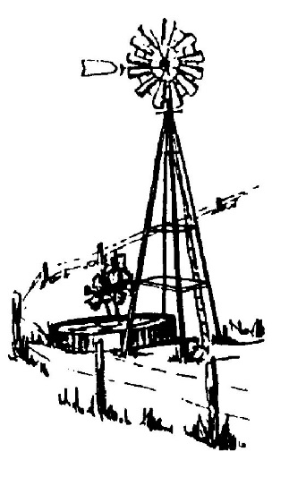
S. S. WATER SUPPLY CORPORATION

SPECIAL BOARD MEETING

AGENDA

Monday, April 17, 2017

7:30 P.M.

Immediately following the Annual Board Meeting

Meeting Called to Order

Conduct Election of Board Members

- President
- Vice President
- Secretary/Treasurer

Approve Corporate Resolution of Names to be listed on:

- Signature Cards for All Accounts at all Banking/Financial Institutions.
- Borrowing any and all monies.
- Authority to sign any documents for sale, purchase and/or trade any land/property, and borrowing or transferring of money.

Appoint Credentials Committee for Next Year

Adjournment of Meeting

_____________________________
JOHN L. LARRISON, PRESIDENT

I, ASHLEY N. LINDSEY, ADMINISTRATIVE ASSISTANT OF THE S.S. WATER SUPPLY CORPORATION, LA VERNIA, TEXAS, DO HEREBY CERTIFY THAT THE ABOVE AGENDA WAS PREPARED AND POSTED ON THE OFFICIAL WEBSITE OF THE CORPORATION ON THIS 13th DAY OFAPRIL, 2017 AT 3:31 PM, WHICH IS A PLACE READILY ACCESSIBLE TO THE PUBLIC AT ALL TIMES AND THAT SAID NOTICE WAS POSTED IN ACCORDANCE WITH CHAPTER 551, TEXAS LOCAL GOVERNMENT CODE.

Ashley N. Lindsey
Ashley N. Lindsey, Administrative Assistant

This Notice is posted pursuant to the Texas Open Meeting Act. (TEX.REV.CIV.STAT.ANN. Chapter 551) S. S. Water Supply Corporation will hold an open meeting at 7:30 p.m., Monday April 17, 2017, at the BUSINESS OFFICE, 10393 U.S. Hwy 87 W, La Vernia, Texas. For more information call 830-779-2837. This facility is accessible in accordance with the Americans with Disabilities Act. Handicapped parking spaces are available. If you require special assistance or have a request for special services please call (830) 779-2837 at least 24 hours in advance of the meeting.

